Supplementary Table 1 Composition and nutrient level of experimental diet.
Diet composition | Content (%)
Corn | 52.9
Wheat Bran | 24
Soybean meal | 15.9
Fish meal | 2
Yeast powder, | 2
Premix | 1
Salt | 0.3
Stone powder | 0.5
Lysine | 0.1
Calcium hydrogen phosphate | 0.12
Multivitamins | 0.02

Analyzed nutrient composition (%)
Crude protein | 16.60
NDF | 19.83
ADF | 5.90
digestibleenergy(MJ/kg) | 12.51

Supplementary Table 2OTU richness and diversity indexes were compared between the two types in NDF and ADF groups.
 | NDF |  |  | ADF
 | H-NDF | L-NDF |  | H-ADF | L-ADF
Shannon | 4.74±0.21^{A} | 4.01±0.25^{B} |  | 4.46±0.26 | 4.05±0.30
Simpson | 0.03±0.01^{b} | 0.06±0.02ª |  | 0.04±0.02 | 0.06±0.02
Ace | 721.87±48.42 | 686.46±48.10 |  | 719.70±28.50 | 672.47±48.50
Chao | 725.85±48.27 | 697.96±53.94 |  | 734.42±36.46 | 681.62±53.68
^{AB} The mean difference is significant at a level of 0.01.

Supplementary Figure 1 Venn diagrams of the OTUs between high and low digestibility groups of NDF and ADF, respectively. L-NDF and L-ADF represent low apparent digestibility of NDF and ADF, H-NDF and H-ADF represent high apparent digestibility of NDF and ADF, respectively.
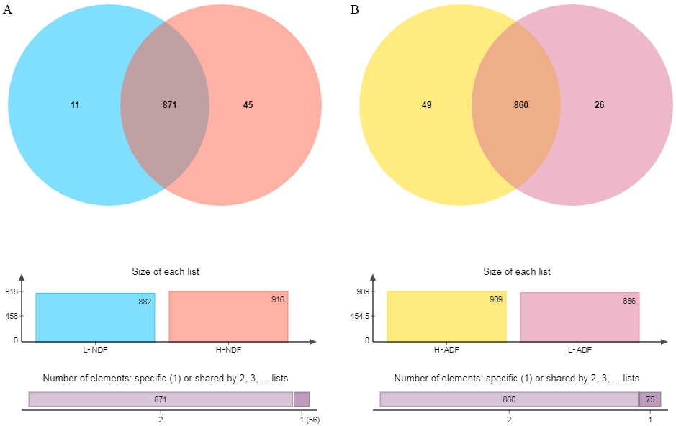

Supplementary Figure 2 Adonis/PERMANOVA. Distance box plot in NDF (A) and ADF (B) groups, respectively.
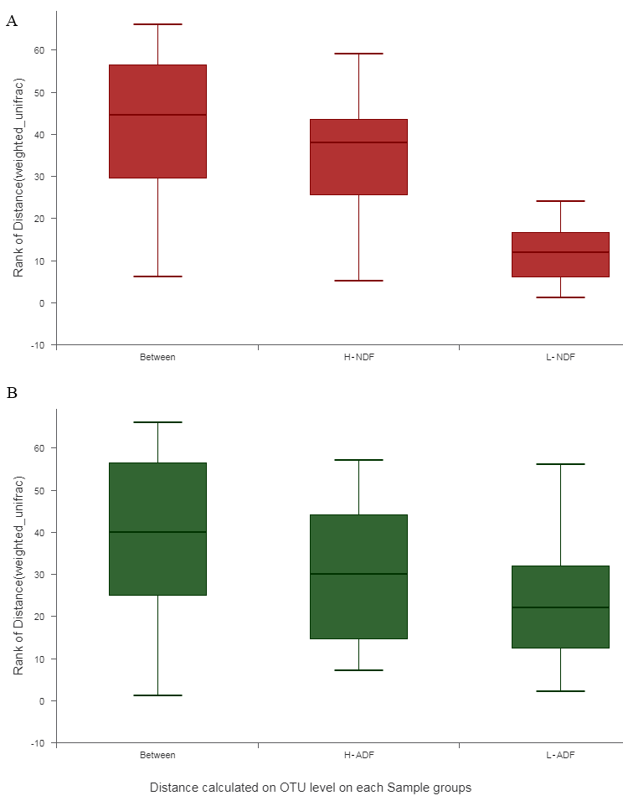

Supplementary Figure 3 A-D Phyla and genera distribution. Phyla and genera distributions as a percentage of the total number in NDF (A and B) and ADF (C and D) groups, respectively. H-NDF and H-ADF groups represent high apparent digestibility of NDF and ADF, L-NDF and L-ADF groups represent low apparent digestibility of NDF and ADF, respectively.
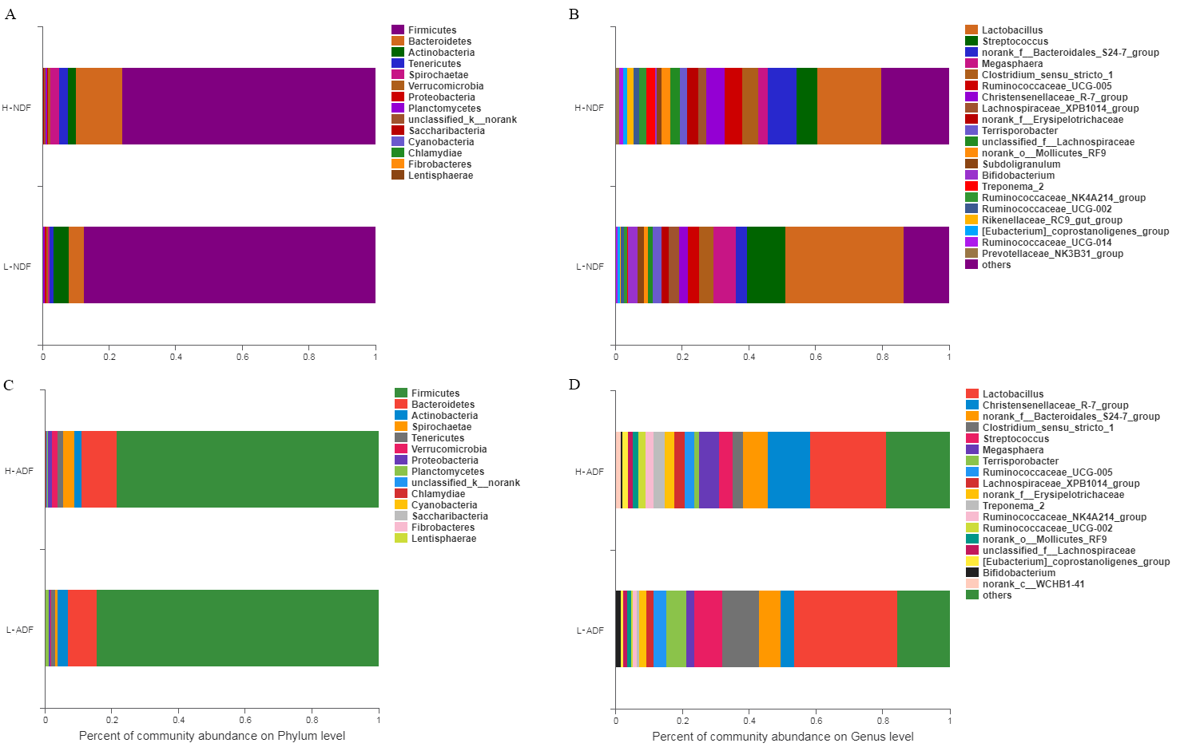

FigureS4 A, B Venn diagrams of the genera between high and low groups of NDF and ADF, respectively. H-NDF and H-ADF represent high apparent digestibility of NDF and ADF, L-NDF and L-ADF represent low apparent digestibility of NDF and ADF, respectively.
